

**Preliminary report**



**Development of a C++ based user-interface for a plasma simulation tool**



**Author: Zhang, Junming (ID: 201138928)**

**Project Supervisor: Mark Bowden**

**Project Assessor:**

**Department of Electrical Engineering and Electronics**

**14 October 2016**

**Declaration of academic integrity**

**I confirm that I have read and understood the University’s Academic Integrity Policy.**

**I confirm that I have acted honestly, ethically and professionally in conduct leading to assessment for the programme of study.**

**I confirm that I have not copied material from another source nor committed plagiarism nor fabricated, falsified or embellished data when completing the attached piece of work. I confirm that I have not copied material from another source, nor colluded with any other student in the preparation and production of this work.**

**SIGNATURE…………………………………………...............................................…………… DATE …………………………............................................................................................**

# Abstract

An existing microplasmas simulation tool which developed by the technological plasma team will generate numerous output data in various formats. Thus a user-friendly-interface is needed from relevant researchers and industry users. In this project, the developing of user-interface is focused on Micro Discharge 2D(pdp_md2d) model and based on C++ environment. One of the major objectives is selecting significant data from a large amount output data based on self-learning knowledge of plasma, another is training programming ability of C++ based developing tools to build a user-friendly-interface. Preliminary research of different user-interface types and rapid text files loading function has been progressed. The future working of this project will according to the project plan in continuing research.

Contents

Abstract 1

1. Introduction 3

2. Project Description 4

2.1 Plasma and Micro Discharge 2D(md2d) model 4

2.1.1 Plasma definition 4

2.1.2 md2d model definition 4

2.2 Project overview 4

3. Methodology 5

3.1 Tools 5

3.1.1 Plasimo 5.0 5

3.1.2 Visual studio 5

3.1.3 Qt 5

3.1.4 openGL 5

3.2 Software Development Process 5

3.2.1 Problem statement 5

3.2.2 Analysis 5

3.2.3 Design 5

4. Project Plan 5

5. Project Rationale and Industrial Relevance 6

6. Literature Review 6

7. Results 6

8. Conclusion 6

References List 6

Appendices 6

Appendix 1. The specification report form 6

Appendix 2. A Gantt chart preferable produced by MS Excel or MS project 6

Appendix 3. The risk assessment form 7

Appendix 4. Ethical approval questionnaire 11

# Introduction

This preliminary report will be divided into 6 main parts:

1. First part is project description. The overview, aims and objectives of this project will be mentioned and then the general ways to realise these aims will be described.
2. Second part is methodology. The specific tools and technological process of this project will be displayed.
3. Third part is project plan and Gantt chart. This project will be divided into specific tasks with duty cycle and then it will be used to generate the Gantt chart for managing the task progress.
4. Fourth part is project rationale and industrial relevance. The evaluation of this project and the research interests of project supervisor will be used to analysis this project and the relationship with industry.
5. Fifth part is literature review. The relevant research results of other people will be browsed and displayed as reference list.
6. Last part is result and conclusion. Preliminary research result of this project will be displayed.

# Project Description

## Plasma and Micro Discharge 2D(md2d) model

### 2.1.1 Plasma definition

### 2.1.2 md2d model definition

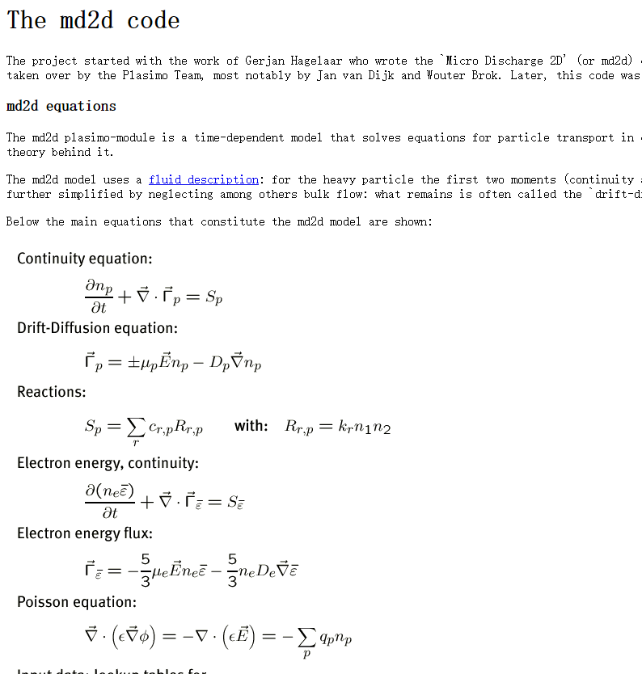

## 2.2 Project overview

There are large amounts of output files generated by an existing simulation tool of microplasmas. Therefore, the aim of this project is to develop a practical C++ based user-interface to help researchers and industry users obtain significant output data effectively.

In order to realize this aim, this project is divided into 2 main parts which are research of plasma to select numerous output data and deep learning of C++developing tool to build the user-interface. Background reading and research for plasma discharges will be involved as an initial phase of this project. At the meanwhile, the skill of developing interface by using C++ based tools should be trained.

Overall, the key aspect of this project is develop the widely accessible user-interface by combined research work and programming skill together.

# Methodology

## Tools

### 3.1.1 Plasimo 5.0

### 3.1.2 Visual studio

### 3.1.3 Qt

### 3.1.4 openGL

## Software Development Process

### 3.2.1 Problem statement

This program is used to display required data by processing large amount of text files. This software should be fitted plasma researchers and industry users.

### 3.2.2 Design

#### 3.2.2.1 Rapid text files loading function

Different output data will be generated by plasma simulation tool with different models, therefore the magnitudes of plasma model may extremely large. Thus the rapid text files loading function is needed to learning and developing.

#### 3.2.2.2 3D graphical display function

For technology users, the output data of plasma simulation should be displayed on both 2D(table) and 3D graphical model, it could support intuitionistic changing of particular plasma model.

#### 3.2.2.3 User-interface building

User-interface is the key aspect of this project, the design of the interface should obey the interface rules(reference)

# Project Plan

## 4.1) FYP

## 4.1.1) Preparatory Work

#### 4.1.1.1) Obtain plasma simulation tool and relevant reading materials

## 4.1.2) Research Work

#### 4.1.2.1) Weekly background reading for plasma discharges.

#### 4.1.2.2) Investigating significant data in numerous output file.

#### 4.1.2.3) Investigating Interface of learning, researching and factory software.

#### 4.1.2.4) Learning of corresponding software include C++ based visual studio, openGL and Qt.

## 4.1.3) Developing Work

#### 4.1.3.1) 3D graphical model display function developed by openGL.

#### 4.1.3.2) Rapid loading text function developed by visual studio.

#### 4.1.3.3) Intuitive user-interface developed by Qt.

## 4.1.4) Report Work

#### 4.1.4.1) Writing project specification report form.

#### 4.1.4.2) Writing Preliminary report.

#### 4.1.4.3) Weekly virtual log book.

#### 4.1.4.4) Preparing presentation.

#### 4.1.4.5) Creating poster.

#### 4.1.4.6) Writing final report.

# Project Rationale and Industrial Relevance

In this project, the major areas related are research of plasma and developing user-interface, which are both significant branches on plasma technology and computer science.

For the continuing development, this project is of high value in both science and

society. The achieved use of the technologies could be lots of benefit for human:

1.

2.

3.

# Literature Review

# Results

# Conclusion

# References List

# Appendices

## Appendix 1. The specification report form

## Appendix 2. A Gantt chart preferable produced by MS Excel or MS project

## Appendix 3. The risk assessment form

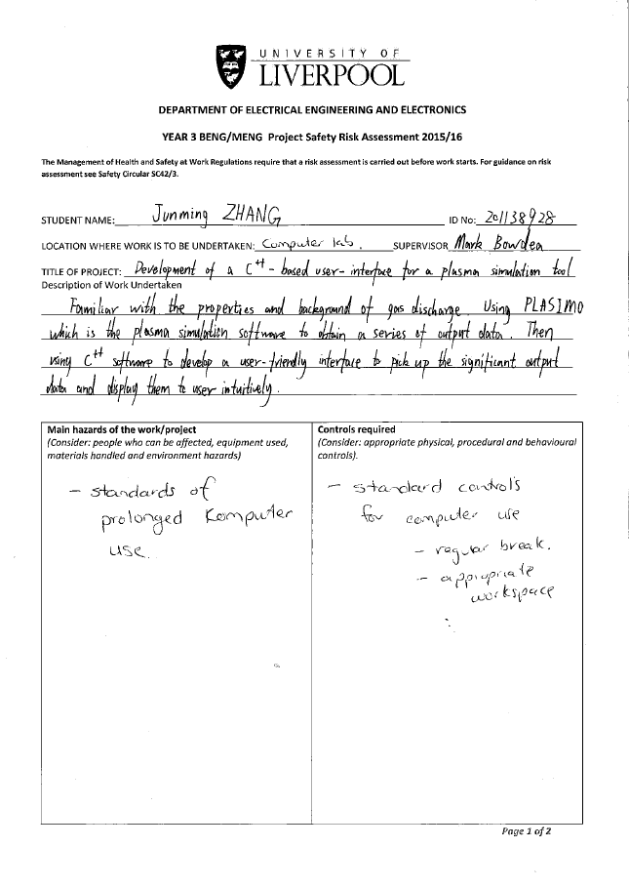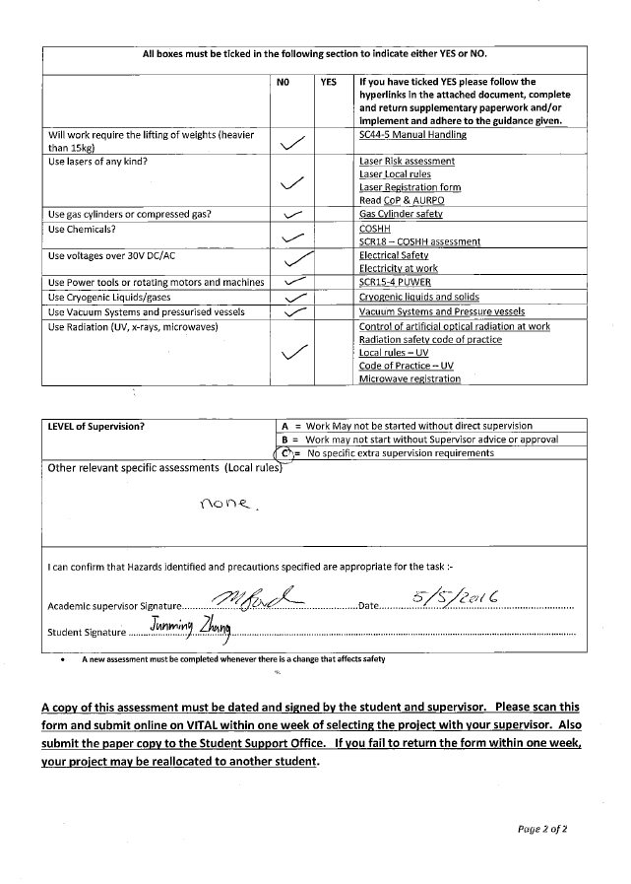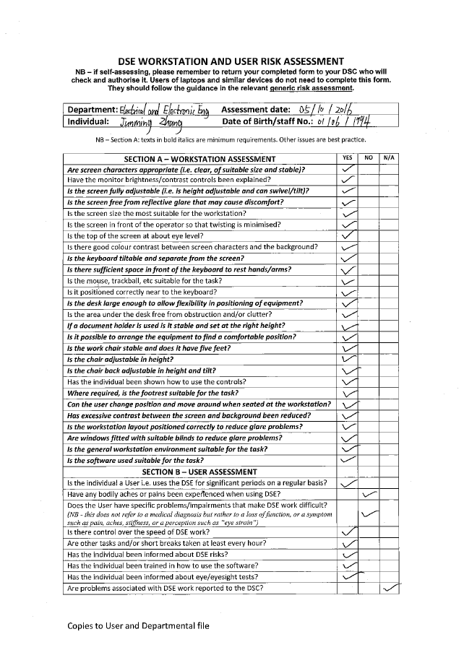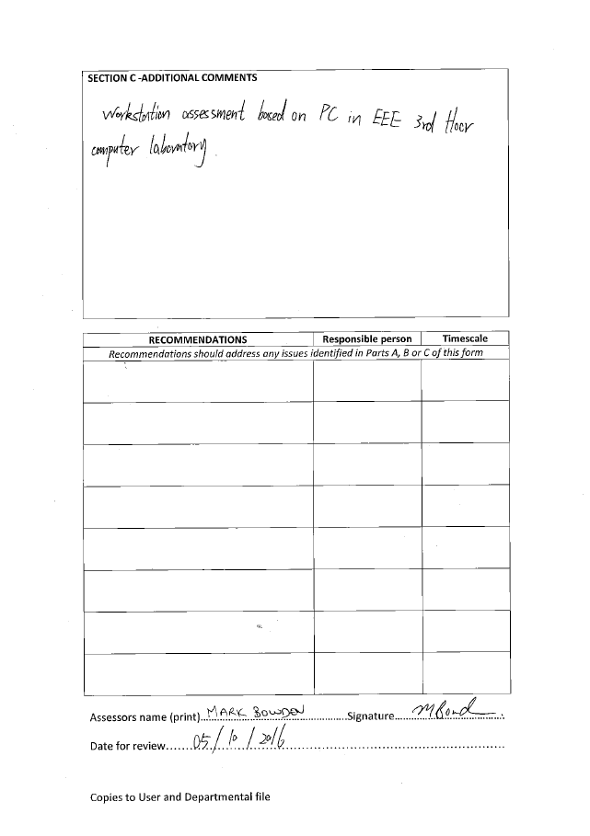

## Appendix 4. Ethical approval questionnaire

